**Year 3 and Year 4 word lists**

|  |  |  |
| --- | --- | --- |
| Term | Year 3 words | Year 4 words |
| Autumn Term 1 | Possessive apostrophe singular and plural words  Homophones list here, hear  heel, heal, he’ll | Tion, sion, ssion, cian  rain, rein, reign whose, who’s  weather, whether |
| ee spelled u: busy, business  split digraphs: arrive, decide, describe, extreme, guide, surprise | tion and sion suffixes: mention, occasion, position, possession, question, |
| Autumn Term 2 | not, knot  male, mail  medal, meddle | Ation, sion  where, wear  where, were |
| words with unstressed vowels: different, favourite, February, interest, library, ordinary, separate | s spelled c before e, i and y: bicycle, centre, century, certain, circle, decide, exercise, experience, medicine, notice, recent |
| Spring Term 1 | Ly suffix  accept, except affect, effect  ball, bawl berry, bury  Sure and ture word endings (as in measure, creature) | Words ending with Ous  plain, plane seen, scene |
| n spelled kn: knowledge, knowledgeable  ~ly and ~ally suffix: accidentally, actually, occasionally, probably | ous endings: famous, various  other words: answer, build, calendar, complete, consider, continue |
| Spring Term 2 | “u” spelled ou (young, double)  Prefixes: un~, dis~, mis~, in~, il~  break, brake fair, fare  great, grate groan, grown | More prefixes: inter, anti, auto, super  weight, wait  eight, ate |
| words with prefixes: disappear, disbelieve, rebuild, reposition  the same words without prefixes: appear, believe, build, position | early, earth, experiment, group, guard, forward, forwards, fruit, heard, heart, history, imagine, important, increase, island |
| Summer Term 1 | “ay” spelled ei eigh ey  Suffixes beginning with vowels added to multi syllable words: ~en, ~ing, ~er, ~ed, ~ation | Long I spelled y in initial and medial positions of word.  More prefixes: inter, re, ir, im |
| ay spelled ei: eight, eighth, reign, weight  igh spelled ei: height | learn, length, material, minute, natural, often, particular, peculiar, perhaps, popular, potatoes, promise, purpose |
| Summer Term 2 | More prefixes: Pre, Sub  main, mane meat, meet  missed, mist piece, peace | K spelled ch  S spelled ch  G spelled gue  K spelled que |
| words with double consonants: address, appear, arrive, different, difficult, disappear, grammar, occasion, opposite, pressure, suppose | quarter, regular, remember, sentence, special, straight, strange, strength, surprise, therefore, woman, women |

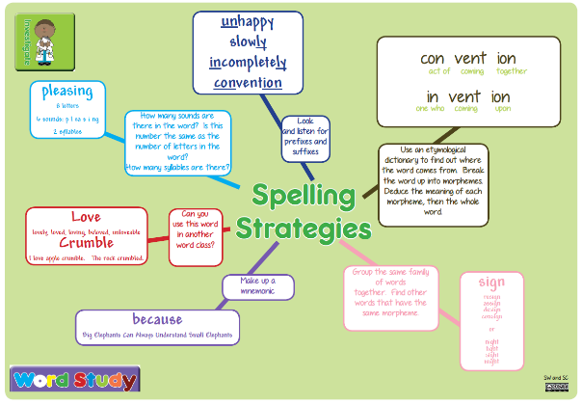

You are learning to spell these words for two reasons. Firstly, they are words that are used regularly in your writing. Secondly, they have been identified as words that every child in your year group in the UK has to be able to spell.

Use your spelling strategy sheet to help you learn ways of remembering how to spell words.

**Year 5 and Year 6 word lists**

|  |  |  |
| --- | --- | --- |
| Term | Year 5 words | Year 6 words |
| Autumn Term 1 | Ough  Cious tious  advice, advise device, devise  licence, license practice, practise  prophecy, prophesy | Words with silent letters: knight, solemn, thistle, doubt, island, lamb  compliment, complement,  descent, dissent |
| ous suffix: disastrous, marvellous, mischievous  I spelled le: available, vegetable, vehicle, muscle  tion suffix: competition, explanation, profession, pronunciation | amateur, average, awkward, bargain, controversy, curiosity, develop, forty, guarantee |
| Autumn Term 2 | Tial and cial endings  i before e rule  farther, further, father  guessed*,* guest  heard, herd  led,lead  morning, mourning  past, passed | desert,  dessert, draft, draught |
| i before ee: achieve, convenience, mischievous  s spelled c before e, I and y: cemetery, conscience, conscious, criticise, excellent, existence, hindrance, necessary, prejudice, sacrifice | harass, hindrance, identity, individual, interfere, interrupt, language, leisure, lightning |
| Spring Term 1 | Words ending with: ant, ance, ancy, ent, ence, ency  precede, proceed  principal, principle  profit, prophet  stationary, stationery | muscle, neighbour, persuade, programme, queue, recognise, relevant, restaurant, rhyme, rhythm |
| Words with unstressed vowels: accommodate  bruise, category, cemetery, definite, desperate, dictionary, embarrass, environment, exaggerate, marvellous, nuisance, parliament, privilege, secretary, vegetable |
| Spring Term 2 | Suffixes beginning with vowels to words ending fer: referring, referred, referral  steal, steel wary, weary  who’s,whose aisle, isle  aloud, allowed affect, effect | shoulder, signature, stomach, temperature, twelfth, vegetable, vehicle, yacht |
| Short i spelled y: physical, symbol, system  Words with prefixes and suffixes: according, attached, criticise, determined, equipment, equipped, especially, frequently, immediate, immediately, necessary, unnecessary, sincere, sincerely |
| Summer Term 1 | Ible able  Ably ibly  Use of hyphen: co-, re- | Revise and consolidate learning of all year 5/6 words |
| Words with double consonants: accommodate, accompany, according, aggressive, apparent, appreciate, attached, committee, communicate, correspond, immediate, occupy, occur, opportunity, recommend, suggest |
| Summer Term 2 | Suffixes beginning with vowels to words ending fer: reference, referee  Long ee spelled ei eg perceive  altar, alter, ascent, assent,  bridal, bridle, cereal, serial  compliment, complement | Revise and consolidate learning of all year 5/6 words |
| Adjacent ie: soldier, sufficient, variety, ancient  No adjacent ie: foreign |

You are learning to spell these words for two reasons. Firstly, they are words that are used regularly in your writing. Secondly, they have been identified as words that every child in your year group in the UK has to be able to spell.

Use your spelling strategy sheet to help you learn ways of remembering how to spell words.